CERTIFICATE Nº 1059/0259-02
In pursuance of the nomination received from Shipper(s), which we summarize hereunder:
EXPORT | TIERRA LEJANA S.A  AV FINCA YERBA BUENA KM 1,2- CENTRO COMERCIAL EL PUNTO 1º PISO 7(4401) SAN LORENZO, SALTA, ARGENTINA.
FISCAL IDENTIFICATION | 30-71243000-8
PURCHASE ORDER NUMBER | 00554 | LIAF CONTROL # ID | 1059
LOT NUMBER | 00554
VESSEL | MAERSK LINS
BOARDING PERMISSION | 25 001 EC01 030793 J
BOOKING | 253604337
BILL OF LADING | 253604337
PRODUCT | GREEN MUNG BEANS
QUANTITY LOADED | TOTAL NET WEIGHT: 200.000 kg  TOTAL GROSS WEIGHT: 200.480 kg
PACKAGING | 8000 BAGS OF 25 kg, IN 8 CONTAINERS
DATE´S INSPECTION | May 20th and 21st, 2025
SAMPLE PLACE | CAPITAN CORTES GROUP  BENJAMIN JUAN LAVAISSE, 1003, PUERTO MADERO.  CIUDAD AUTONOMA DE BUENOS AIRES
PORT OF DESTINATION | HAIPHONG, VIETNAM
PORT OF LOADING | BUENOS AIRES, ARGENTINA
CONSIGNEE | NARA FOODS COMPANY LIMITED  TK 3/2, CO NOI COMMUNE, MAI SON DISTRICT,  SON LA PROVINCE, VIETNAM
NOTIFY PARTY | NARA FOODS COMPANY LIMITED  TK 3/2, CO NOI COMMUNE, MAI SON DISTRICT,  SON LA PROVINCE, VIETNAM
Weight: We, LIAF CONTROL SRL, certify having supervised the loading of the above mentioned, verifying control of weight according to GAFTA Weighing Rule 123 (01/01/2022); GAFTA Approved Register for Superintendents: Code of practice (Version 3.0 December 2021, Effective from 1 January 2022)
Quantity: We were present at time of stuffing the containers mentioned, according to below details:
CONTAINERS | BAGS | LIAF CONTROL SEAL Nº | CUSTOMS SEAL Nº | NET WEIGHT (kg) | GROSS WEIGHT (kg)
MRKU 990574-0 | 1000 | 4904 | BAH 33457 | 25.000 | 25.060
MSKU 589474-1 | 1000 | 4905 | BAH 33462 | 25.000 | 25.060
XINU 157344-0 | 1000 | 4906 | BAH 33456 | 25.000 | 25.060
MRKU 807197-7 | 1000 | 4907 | BAH 33461 | 25.000 | 25.060
MRKU 714075-4 | 1000 | 4908 | BAH 33455 | 25.000 | 25.060
MRKU 658582-7 | 1000 | 4909 | BAH 33454 | 25.000 | 25.060
MRKU 943634-4 | 1000 | 4910 | BAH 33453 | 25.000 | 25.060
TRHU 384128-4 | 1000 | 4911 | BAH 33452 | 25.000 | 25.060
The data refer only on the date and time of the Inspection, and do not refer to any other matters.
PLACE AND DATE ISSUE CERTIFICATE: Buenos Aires City, June 26, 2025 | 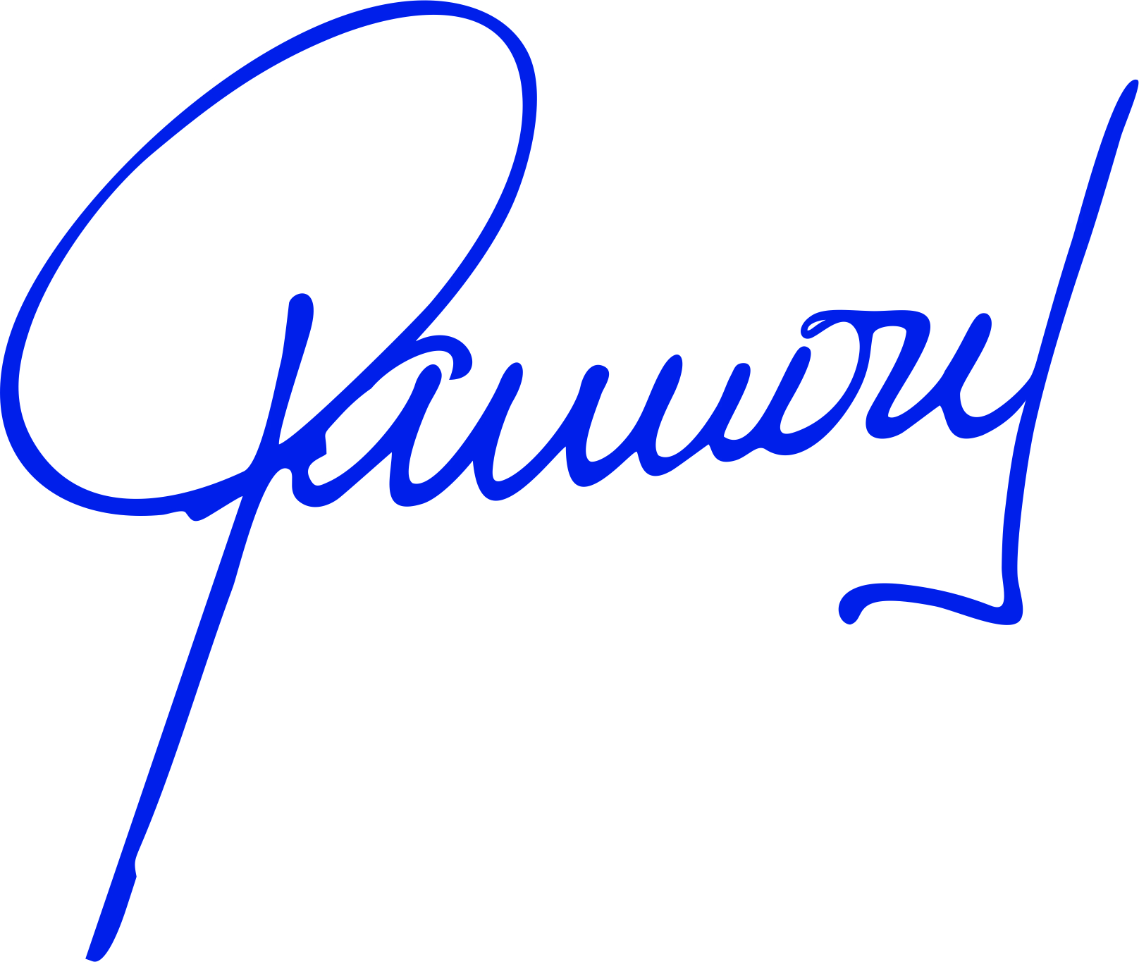  Signature of Authorized Personnel  LIAF CONTROL SRL

